TYPESCRIPT OVERVIEW:
TypeScript lets you write JavaScript the way you really want to. TypeScript is a typed superset of JavaScript that compiles to plain JavaScript. TypeScript is pure object oriented with classes, interfaces and statically typed like C# or Java. The popular JavaScript framework Angular 2.0 is written in TypeScript. Mastering TypeScript can help programmers to write object-oriented programs and have them compiled to JavaScript, both on server side and client side.

TypeScript - Overview

JavaScript was introduced as a language for the client side. The development of Node.js has marked JavaScript as an emerging server-side technology too. However, as JavaScript code grows, it tends to get messier, making it difficult to maintain and reuse the code. Moreover, its failure to embrace the features of Object Orientation, strong type checking and compile-time error checks prevents JavaScript from succeeding at the enterprise level as a full-fledged server-side technology. TypeScript was presented to bridge this gap.

What is TypeScript?

By definition, “TypeScript is JavaScript for application-scale development.”
TypeScript is a strongly typed, object oriented, compiled language. It was designed by Anders Hejlsberg (designer of C#) at Microsoft. TypeScript is both a language and a set of tools. TypeScript is a typed superset of JavaScript compiled to JavaScript. In other words, TypeScript is JavaScript plus some additional features.
Features of TypeScript
TypeScript is just JavaScript. TypeScript starts with JavaScript and ends with JavaScript. Typescript adopts the basic building blocks of your program from JavaScript. Hence, you only need to know JavaScript to use TypeScript. All TypeScript code is converted into its JavaScript equivalent for the purpose of execution.
TypeScript supports other JS libraries. Compiled TypeScript can be consumed from any JavaScript code. TypeScript-generated JavaScript can reuse all of the existing JavaScript frameworks, tools, and libraries.
JavaScript is TypeScript. This means that any valid .js file can be renamed to .ts and compiled with other TypeScript files.
TypeScript is portable. TypeScript is portable across browsers, devices, and operating systems. It can run on any environment that JavaScript runs on. Unlike its counterparts, TypeScript doesn’t need a dedicated VM or a specific runtime environment to execute.

TypeScript and ECMAScript
The ECMAScript specification is a standardized specification of a scripting language. There are six editions of ECMA-262 published. Version 6 of the standard is codenamed "Harmony". TypeScript is aligned with the ECMAScript6 specification.
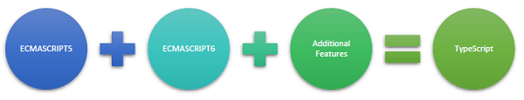
TypeScript adopts its basic language features from the ECMAScript5 specification, i.e., the official specification for JavaScript. TypeScript language features like Modules and class-based orientation are in line with the EcmaScript 6 specification. Additionally, TypeScript also embraces features like generics and type annotations that aren’t a part of the EcmaScript6 specification.

Why Use TypeScript?
TypeScript is superior to its other counterparts like CoffeeScript and Dart programming languages in a way that TypeScript is extended JavaScript. In contrast, languages like Dart, CoffeeScript are new languages in themselves and require language-specific execution environment.
The benefits of TypeScript include −
- Compilation − JavaScript is an interpreted language. Hence, it needs to be run to test that it is valid. It means you write all the codes just to find no output, in case there is an error. Hence, you have to spend hours trying to find bugs in the code. The TypeScript transpiler provides the error-checking feature. TypeScript will compile the code and generate compilation errors, if it finds some sort of syntax errors. This helps to highlight errors before the script is run.
- Strong Static Typing − JavaScript is not strongly typed. TypeScript comes with an optional static typing and type inference system through the TLS (TypeScript Language Service). The type of a variable, declared with no type, may be inferred by the TLS based on its value.
- TypeScript supports type definitions for existing JavaScript libraries. TypeScript Definition file (with .d.ts extension) provides definition for external JavaScript libraries. Hence, TypeScript code can contain these libraries.
- TypeScript supports Object Oriented Programming concepts like classes, interfaces, inheritance, etc.

Components of TypeScript
At its heart, TypeScript has the following three components −
- Language − It comprises of the syntax, keywords, and type annotations.
- The TypeScript Compiler − The TypeScript compiler (tsc) converts the instructions written in TypeScript to its JavaScript equivalent.
- The TypeScript Language Service − The "Language Service" exposes an additional layer around the core compiler pipeline that are editor-like applications. The language service supports the common set of a typical editor operations like statement completions, signature help, code formatting and outlining, colorization, etc.

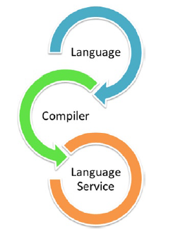

Declaration Files
When a TypeScript script gets compiled, there is an option to generate a declaration file (with the extension .d.ts) that functions as an interface to the components in the compiled JavaScript. The concept of declaration files is analogous to the concept of header files found in C/C++. The declaration files (files with .d.ts extension) provide intellisense for types, function calls, and variable support for JavaScript libraries like jQuery, MooTools, etc.

A Text Editor
The text editor helps you to write your source code. Examples of a few editors include Windows Notepad, Notepad++, Emacs, vim or vi, etc. Editors used may vary with Operating Systems.
The source files are typically named with the extension .ts

The TypeScript Compiler
The TypeScript compiler is itself a .ts file compiled down to JavaScript (.js) file. The TSC (TypeScript Compiler) is a source-to-source compiler (transcompiler / transpiler).
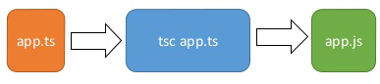
The TSC generates a JavaScript version of the .ts file passed to it. In other words, the TSC produces an equivalent JavaScript source code from the Typescript file given as an input to it. This process is termed as transpilation.
However, the compiler rejects any raw JavaScript file passed to it. The compiler deals with only .ts or .d.ts files.

TypeScript - Basic Syntax
Syntax defines a set of rules for writing programs. Every language specification defines its own syntax. A TypeScript program is composed of −
- Modules
- Functions
- Variables
- Statements and Expressions
- Comments

Your First TypeScript Code
Let us start with the traditional “Hello World” example −
var message:string = "Hello World"
console.log(message)
On compiling, it will generate following JavaScript code.
//Generated by typescript 1.8.10
var message = "Hello World";
console.log(message);
- Line 1 declares a variable by the name message. Variables are a mechanism to store values in a program.
- Line 2 prints the variable’s value to the prompt. Here, console refers to the terminal window. The function log () is used to display text on the screen.

Compile and Execute a TypeScript Program
Let us see how to compile and execute a TypeScript program using Visual Studio Code. Follow the steps given below −
Step 1 − Save the file with .ts extension. We shall save the file as Test.ts. The code editor marks errors in the code, if any, while you save it.
Step 2 − Right-click the TypeScript file under the Working Files option in VS Code’s Explore Pane. Select Open in Command Prompt option.
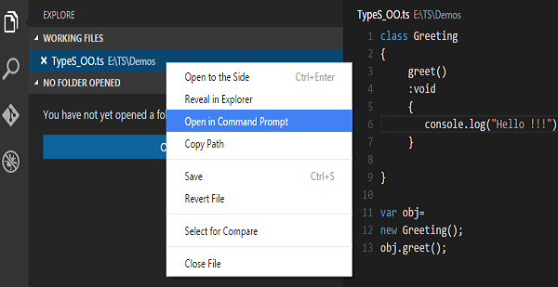
Step 3 − To compile the file use the following command on the terminal window.
tsc Test.ts
Step 4 − The file is compiled to Test.js. To run the program written, type the following in the terminal.
node Test.js

Compiler Flags
Compiler flags enable you to change the behavior of the compiler during compilation. Each compiler flag exposes a setting that allows you to change how the compiler behaves.
The following table lists some common flags associated with the TSC compiler. A typical command-line usage uses some or all switches.
S.No. | Compiler flag & Description
1. | --help  Displays the help manual
2. | --module  Load external modules
3. | --target  Set the target ECMA version
4. | --declaration  Generates an additional .d.ts file
5. | --removeComments  Removes all comments from the output file
6. | --out  Compile multiple files into a single output file
7. | --sourcemap  Generate a sourcemap (.map) files
8. | --module noImplicitAny  Disallows the compiler from inferring the any type
9. | --watch  Watch for file changes and recompile them on the fly
Note − Multiple files can be compiled at once.
tsc file1.ts, file2.ts, file3.ts

Identifiers in TypeScript
Identifiers are names given to elements in a program like variables, functions etc. The rules for identifiers are −
- Identifiers can include both, characters and digits. However, the identifier cannot begin with a digit.
- Identifiers cannot include special symbols except for underscore (_) or a dollar sign ($).
- Identifiers cannot be keywords.
- They must be unique.
- Identifiers are case-sensitive.
- Identifiers cannot contain spaces.
The following tables lists a few examples of valid and invalid identifiers −
Valid identifiers | Invalid identifiers
firstName | Var
first_name | first name
num1 | first-name
$result | 1number

TypeScript ─ Keywords
Keywords have a special meaning in the context of a language. The following table lists some keywords in TypeScript.
break | as | any | switch
case | if | throw | else
var | number | string | get
module | type | instanceof | typeof
public | private | enum | export
finally | for | while | void
null | super | this | new
in | return | true | false
any | extends | static | let
package | implements | interface | function
new | try | yield | const
continue | do | catch

Whitespace and Line Breaks
TypeScript ignores spaces, tabs, and newlines that appear in programs. You can use spaces, tabs, and newlines freely in your program and you are free to format and indent your programs in a neat and consistent way that makes the code easy to read and understand.

TypeScript is Case-sensitive
TypeScript is case-sensitive. This means that TypeScript differentiates between uppercase and lowercase characters.

Semicolons are optional
Each line of instruction is called a statement. Semicolons are optional in TypeScript.
Example
console.log("hello world")
console.log("We are learning TypeScript")
A single line can contain multiple statements. However, these statements must be separated by a semicolon.

Comments in TypeScript
Comments are a way to improve the readability of a program. Comments can be used to include additional information about a program like author of the code, hints about a function/ construct etc. Comments are ignored by the compiler.
TypeScript supports the following types of comments −
- Single-line comments ( // ) − Any text between a // and the end of a line is treated as a comment
- Multi-line comments (/* */) − These comments may span multiple lines.
Example
//this is single line comment

/* This is a
Multi-line comment
*/

TypeScript and Object Orientation
TypeScript is Object-Oriented JavaScript. Object Orientation is a software development paradigm that follows real-world modelling. Object Orientation considers a program as a collection of objects that communicate with each other via mechanism called methods. TypeScript supports these object oriented components too.
- Object − An object is a real time representation of any entity. According to Grady Brooch, every object must have three features −
  - State − described by the attributes of an object
  - Behavior − describes how the object will act
  - Identity − a unique value that distinguishes an object from a set of similar such objects.
- Class − A class in terms of OOP is a blueprint for creating objects. A class encapsulates data for the object.
- Method − Methods facilitate communication between objects.
Example: TypeScript and Object Orientation
class Greeting {
greet():void {
console.log("Hello World!!!")
}
}
var obj = new Greeting();
obj.greet();
The above example defines a class Greeting. The class has a method greet (). The method prints the string “Hello World” on the terminal. The new keyword creates an object of the class (obj). The object invokes the method greet ().
On compiling, it will generate following JavaScript code.
//Generated by typescript 1.8.10
var Greeting = (function () {
function Greeting() {
}
Greeting.prototype.greet = function () {
console.log("Hello World!!!");
};
return Greeting;
}());

var obj = new Greeting();
obj.greet()
The output of the above program is given below −
Hello World!!!

